USGS *Phragmites* Management Support

Prepared by Dr. Kurt Kowalski, U.S. Geological Survey

Summary of Outputs and Outcomes 2015

USGS used GLRI funding to work within an Integrated Pest Management (IPM) framework to engage partners and initiate several related projects resulting in regional collaboration and action of unprecedented levels. Many printed and digital products were produced or are in progress. We have changed the way people think about and approach the issues surrounding *Phragmites* in the Great Lakes basin. Here we highlight significant accomplishments to date. Find more details for each below.

Great Lakes Phragmites Collaborative: The Great Lakes *Phragmites* Collaborative (GLPC) was formed in 2012 to engage stakeholders and maximize the collective impact of efforts to control *Phragmites* by coordinating people, information, and action through facilitated meetings, an extensive web site, webinars, blogs, and other forms of social media. The collaborative has played an integral role in initiating and organizing many other projects.

Adaptive Management: The GLPC will continue to play a significant role in development and implementation of the recently initiated basin-wide project titled: A *Phragmites* Adaptive Management Framework.

Mapping and Vulnerability: In 2013, the Journal of Great Lakes Research published results from a significant mapping study that used PALSAR radar data to produce the first U.S. coastal Great Lakes distribution map of *Phragmites australis*. This map showed 24,643 ha of large (> 0.2 ha), dense stands of invasive *Phragmites* within the coastal zone. Using these data along with landscape-scale environmental data, we forecasted areas that may be highly vulnerable to new *Phragmites* invasion.

Innovative Control (1): Working with Wayne State University, we continue to make progress testing gene silencing as a means of *Phragmites* management. Genes regulating photosynthesis have been silenced in two model plants (maize and spinach), producing stunted growth. We recently led a pioneering effort to sequence and analyze the *Phragmites* transcriptome (manuscript in prep), which will allow us to target particular traits for control. We are currently testing effective transmission vectors on the way to field trials in *Phragmites*.

Innovative Control (2): A collective impact approach was used to form the *Phragmites* Symbiosis Collaborative (PSC). The PSC, an international team of 12 scientists specializing in plant-microbial symbiosis, developed a conceptual framework for studying the microbial interactions associated with *Phragmites*. In February 2015, the PSC published a science agenda in Frontiers in Microbiology that established a guide for new projects in this field and will maintain the collective focus on the ultimate goal of a *Phragmites* management approach based on microbial symbiosis.

Innovative Control (3): The PSC helped initiate several ongoing studies between USGS and collaborators at Indiana University, Rutgers University, and other institutions to investigate the roles that fungal and bacterial endophytes play in *Phragmites* invasion. Results from these collaborative efforts are being communicated via presentations and manuscripts in professional journals.

The Great Lakes *Phragmites* Collaborative

The Great Lakes *Phragmites* Collaborative (GLPC) is an initiative led by a core team supported by staff from USGS – Great Lakes Science Center and the Great Lakes Commission (GLC), with oversight and input from an international Advisory Committee. The goal of the GLPC is to form regional partnerships to promote more coordinated, efficient, and strategic approaches to *Phragmites* management, restoration, and research in the eight states and two Canadian provinces in the Great Lakes basin. The GLPC serves as a communication conduit via an interactive website, a webinar series, and several social media outlets that facilitate access to information, encourage technology transfer, and build connections between habitat managers, governmental agencies, and private landowners.

The organization and involvement from the Advisory Committee has helped to organize many of the most recent *Phragmites* research and management developments including:

* Allowing involved parties (e.g. state agencies, non-for-profits, land managers) to communicate more effectively and on a regular basis, reduce redundancies, and improve efficiencies in *Phragmites* research and management
* Identifying a list of *Phragmites* management and research needs including mapping and forecasting the spread of the plant, more effective and innovative control strategies, best management practices, and an adaptive management framework

By the numbers

Between June 2012 and mid-2015, the Collaborative organized:

17 hour-long webinars averaging 89 live viewers; 28 Phragmites-related blog posts

Social media presence included:

>18,000 annual unique users on the GLPC web page; 566 email listerv users

268 Facebook likes; 448 Twitter followers

Professional conference presentations

3 oral presentations; 2 poster presentations

Publications

USGS and GLC are preparing a manuscript detailing the GLPC and using it as a model for the use of the collective impact approach.

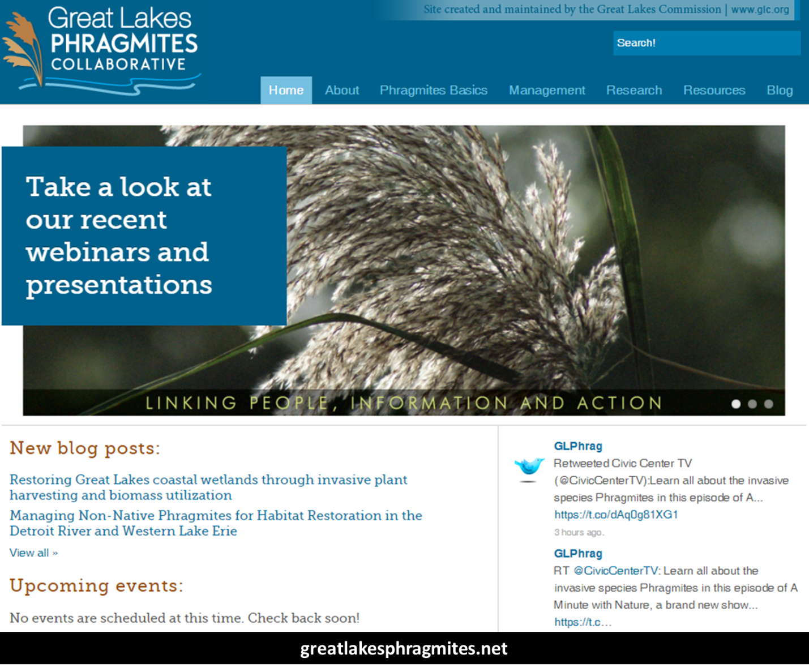

Basin-wide *Phragmites* Mapping and Vulnerability Mapping

To understand the extent of the *Phragmites* problem in the Great Lakes coastal zone, a mapping exercise was completed using PALSAR satellite imagery to identify large stands of non-native *Phragmites*. This effort produced the first U.S. coastal Great Lakes distribution map of *Phragmites australis*, which identified 24,643 ha of large (> 0.2 ha), dense stands of non-native *Phragmites*.

Using the basin-scale distribution map, environmental data (e.g., soils, nutrients, disturbance, climate, topography), and climate predictions, we performed analyses of current and predicted suitable coastal habitat. We also investigated differential influences of environmental variables in the upper lakes (Lakes Superior, Michigan, and Huron) and lower lakes (Lakes St. Clair, Erie, and Ontario). The results of this study, combined with a publicly available online GLRI *Phragmites* Decision Support Tool (DST), enable resource managers and restoration practitioners to target and prioritize *Phragmites* control efforts in the Great Lakes coastal zone.

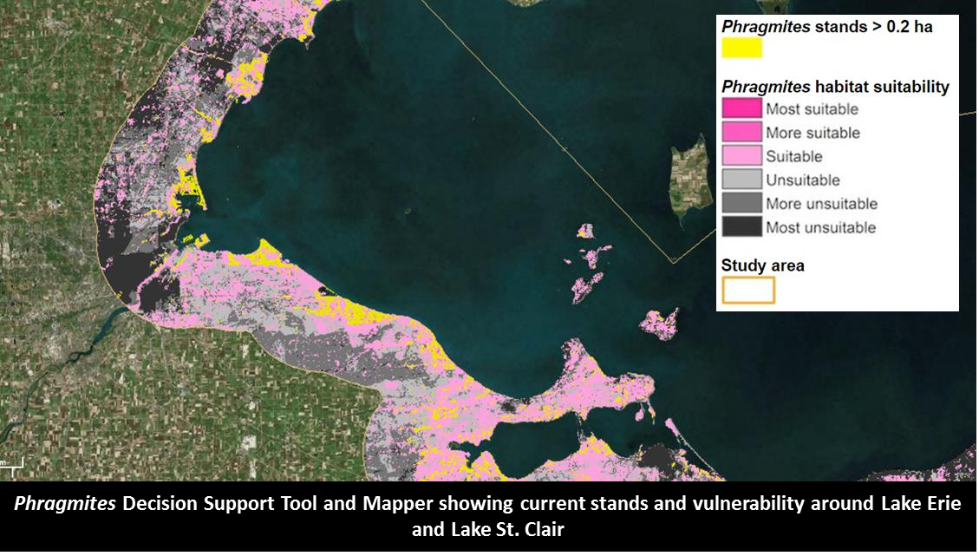

Publications

Bourgeau-Chavez, L.L., et al. 2013. Mapping invasive *Phragmites* *australis* in the coastal Great Lakes with ALOS PALSAR satellite imagery for decision support. Journal of Great Lakes Research 39(Supplement 1):65-77.

Carlson Mazur, M.L., K.P. Kowalski, and D. Galbraith. 2014. Assessment of suitable habitat for *Phragmites australis* (common reed) in the Great Lakes coastal zone. Aquatic Invasions 9(1):1-19.

Presentations

Huberty, B., L. Bourgeau-Chavez, K. Kowalski, and M. Renz. Multiscale *Phragmites* Mapping and its Aoplication. Great Lakes Phragmites Collaborative Webinar Series. February 6, 2013.

Gene Silencing for *Phragmites* Management

Researchers at Wayne State University, in cooperation with the USGS-GLSC, are exploring the use of gene silencing as a means of *Phragmites* management. This genetic approach is seeking a species-specific control option for managers, which could be very useful in sensitive areas or areas where conventional control efforts are not available.

RNA-based gene silencing disrupts the transmission of genetic information necessary for protein synthesis and trait development. Thus, if genes integral in photosynthesis (for example) are silenced, the plant effectively will fail to produce energy for itself.

We sequenced the transcriptome (all of the RNA codes that make proteins in the plant) of *Phragmites* *australis* to create a genetic road-map that will guide future targets for knockdown of gene expression via constructed vectors.

Competition experiments will be carried out between 'silenced' plants and non-silenced plants. Field trials will begin once a reduction in competitive abilities are documented.

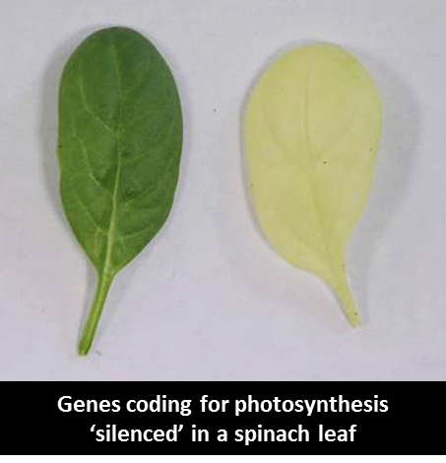

Publications

Golenberg, E., K. P. Kowalski, and W. Bickford. 2014. Transcriptome analysis of field collected *Phragmites australis*: differential expression patterns and pathogen/herbivore imprints on a tissue-specific level (In Prep).

Presentations

Golenberg, E. 2013. Great Lakes *Phragmites* Collaborative Webinar Series. Nov 22, 2013.

*Phragmites* Symbiosis Collaborative

Building off the success from the Great Lakes *Phragmites* Collaborative, we set out to use a collective impact approach to advance the science of microbial symbiosis in *Phragmites* and identify management targets. Assisted by partners at the Great Lakes Commission, we put together an international group consisting of 12 scientists who meet regularly to assess the state of the science and identify research gaps. In February 2015, we published a science agenda in Frontiers in Microbiology; this paper is being used as a guide for new projects in this field and will maintain the collective focus on the ultimate goal of a *Phragmites* management approach based on microbial symbiosis.

As a direct result of assembling this group, USGS has formed new relationships with other research labs and is contributing directly to collaborative research efforts exploring the role of bacterial and fungal endophytes in invasive *Phragmites*.

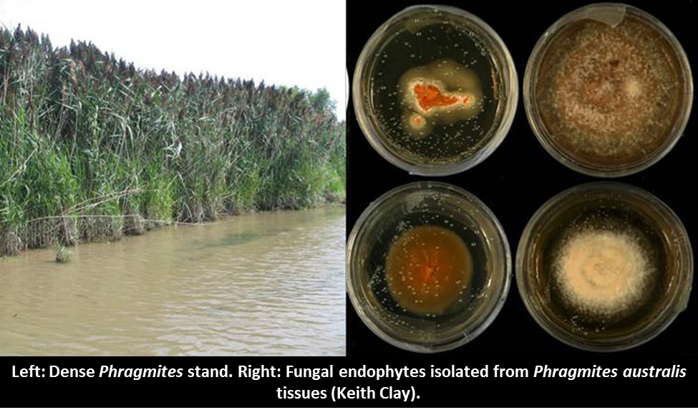

In collaboration with Indiana University, we are exploring the role of fungal endophytes in the invasion success of *Phragmites* to determine if and how these organisms are providing any advantage to this extremely invasive plant. We are conducting additional research with collaborators at Rutgers University focused on bacterial endophytes within *Phragmites*. Both of these research projects are intended to develop the potential for microbial-based *Phragmites* management opportunities.

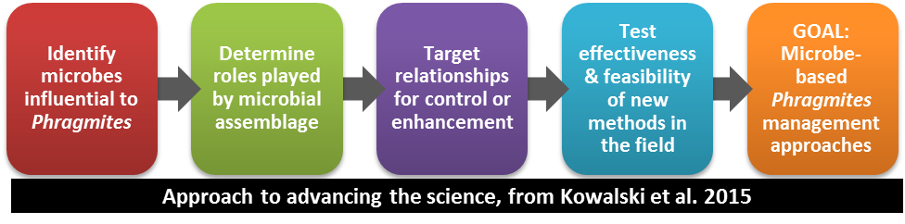

Additional partners: U.S. Department of Agriculture, Rutgers University, Smithsonian Environmental Research Center, Great Lakes Commission, Cornell University, State University of New York-Brockport.

Publications

Kowalski, K.P., et al. 2015. Advancing the science of microbial symbiosis to support invasive species management: a case study on *Phragmites* in the Great Lakes. Frontiers in Microbiology 6:1-14.

Several papers in review

Presentations

Clay, K., K. P. Kowalski, Z. Shearin, W. Bickford, K. Bourke. Exploring fungal endophyte diversity in invasive *Phragmites australis*. Society of Wetlands Scientists Conference. June 2015.

Kowalski, K. P., W. Bickford, D. Wilcox, R. J. Rodriguez. A microbial approach to *Phragmites* management. Society of Wetlands Scientists Conference. June 2013.

Bickford, W., K. P. Kowalski. Developing microbe-based management strategies for invasive Phragmites australis. International Association of Great Lakes Research Conference. May 2014.

Putting it all together: *Phragmites* Adaptive Management Framework

Facilitated by the Great Lakes *Phragmites* Collaborative, we are spear-heading an integrated effort to develop a regional adaptive management framework for *Phragmites* that is based on principles of structured decision making. Fueled by stakeholder involvement and on-the-ground data collection, this effort seeks to change the way *Phragmites* is managed at the patch and landscape scales.

The new integrated approach will build on existing successful programs (e.g., Native Prairie Adaptive Management) and resources (USFWS *Phragmites* adaptive management plan for the refuge system) to develop a framework suitable for basin-wide implementation. The core of the framework will involve standardized scalable monitoring protocols and a centralized data management system that supports large-scale state/transition models. As managers populate the database with on-the-ground data, management guidelines will adapt to reflect the most successful techniques applied in the given system. Patch- and landscape-scale guidance will be produced to assist land managers with annual decisions regarding *Phragmites* management.

The core USGS development team, the Great Lakes Commission, and many other partners will engage a suite of private, non-profit, and governmental partners to maximize basin-wide participation and investment by resource managers. Components of the framework will be improved with time based on user feedback and advances in technologies.

Partners: U.S. Fish & Wildlife Service, Ducks Unlimited, The Nature Conservancy, Huron Pines, Ohio Department of Natural Resources, Great Lakes Commission, Michigan Department of Natural Resources, Wisconsin Department of Natural Resources.

